## [SWEEGLU ELLIOTT WAVES 38% RETRACEMENT BREAKOUT TRADING STRATEGY](http://sweeglu.com/sweeglu-elliott-waves-38-retracement-breakout-trading-strategy/" \o "Permanent Link to SWEEGLU ELLIOTT WAVES 38% RETRACEMENT BREAKOUT TRADING STRATEGY)

Sweeglu Elliott Waves is going to share most Accurate and Profitable Trading Strategy based on 38% retracement breakout of Elliott Wave Theory. People say 61% is Golden Retracement Fibonacci Ratio, but we are going to prove with real life facts and examples that 38% retracement is way more golden than 61% and it can make a trader rich if he/she knows how and when to use it.

**Sweeglu Elliott Waves 38% Retracement Breakout Strategy:**

The 38% retracement breakout trading strategy which we are going to share in this article is not something like secret. We are not saying it as secret because Sweeglu Elliott Waves never keep secrets, we always provide our Stock Market outlook with detailed analysis and calculations, and everything whatever we are doing is on our website. Even we suggest trades with reason and chart explanation to our clients.

We are declaring this Sweeglu Elliott Waves 38% retracement trading strategy as most accurate and profitable because we can earn a good profit with lowest risk even if we are wrong at overall Elliott Wave Counting. And this single Sweeglu Elliott Waves trading strategy alone is capable to transform your analysis and trading to the professional level.

Before explaining the techniques and calculations of 38% retracement breakout trading strategy, we want to advise readers that read this article very carefully without missing a line because every word is important. This article is bit lengthy because we tried to explain it in such a way that even a newbie can understand. Investing some time in reading this article and comparing the written explanation with charts will provide you the roadmap to success in Stock Market Analysis and Trading which you will not get anywhere else even if you pay 1000s.  Even experienced Stock Market Analysts and researchers will get a worthy subject for their research. This single article is worthy than most of the costly books and courses available in the market. So let’s start from the Simple end.

We are starting the explanation with a recent Nifty trade which we suggested to our “Live Update Subscribers” recently on 01 Oct 2019 because that trade was based on this 38% retracement breakout trading strategy. We generally provide detailed explanation of our market outlook and trades using charts but Nifty is so volatile now days that we tend to miss good trading opportunities if we concentrate on preparing charts for clients. So, we are just providing outlook and trades now days so that we don’t miss the opportunity by the time we prepare chart.

A Nifty selling trade was suggested to “Live Update Subscribers” on 01 Oct 2019. Nifty registered day’s high 10554 and declined back. Later selling was suggested on bounce after touching 11487 in 11498-11512 range using exact stoploss of 11523 expecting 11408 as minimum downside target.

The exact wording of Live Update and Trade is on the WhatsApp Screenshot below: –

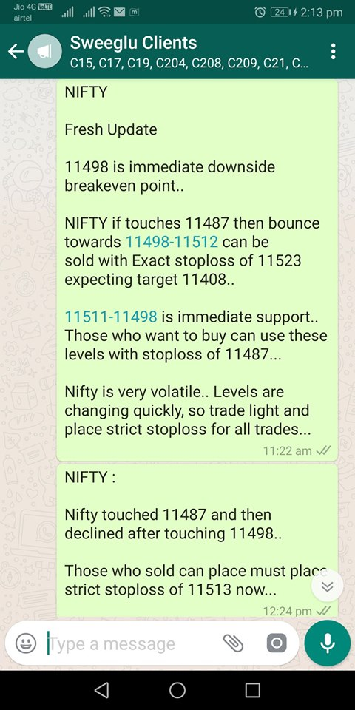

Now let me explain the reason and calculations behind this trade on chart: –

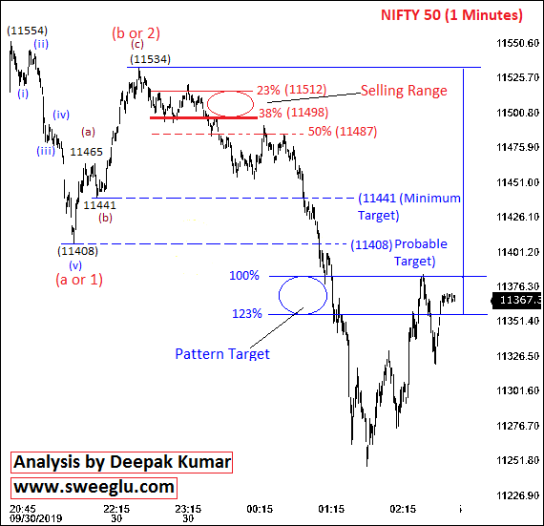

This is 01 Minutes time bar chart of Nifty covering Intraday move of 01 Oct 2019.

Please have a careful look at chart and try to identify the bounce from 11408-11534. The bounce from 11408-11534 looks a 3 waves move with 1st wave (a) completed from 11408-11465, 2nd wave (b) completed from 11465-11441 and 3rd wave (c) completed from 11441-11534.

Within this 3 waves (abc) bounce from 11408-11534, 3rd wave (c) from 11441-11534 is important. 23% retracement of wave (c) is placed at 11512, 38% retracement of this wave (c) is placed at 11498 and 50% retracement of this wave (c) is placed at 11487.

38% retracement of wave (c) 11498 was trend reversal point and we call it Breakeven Point. Trading strategy was to sell Nifty after break below 38% retracement (breakeven point) for minimum target 11408 [start of (abc) move].

To confirm the break below 38% retracement 11498, we waited for the touch of 50% retracement 11487. When Nifty touched 11487 then we waited for bounce towards 38%-23% retracement 11498-11512 to sell with stoploss of 11523 (11 points above 23% retracement 11512).

Maximum Stoploss was 25 points (from entry point 11498) and minimum target was 90 points (11498-11408 = 90). This trade was giving minimum 90 points profit with risk of maximum 25 points and remember, 90 points profit was minimum whereas maximum profit could extend anywhere and maximum stoploss was just 25 points. Means, Profit ratio could extend and loss ratio could be reduced. Minimum Risk Reward for the trade was 1:3.

Minimum target according to Sweeglu Elliott Waves 38% retracement trading strategy was 11441 (start of wave (c)] but I suggested minimum target as 10408 based on overall pattern. Even minimum target of 11441 was giving risk reward of more than 1:2.

Now have a careful look at the chart again to see what happened next. Nifty touched 11487 and then bounced to touch entry range 11498 and declined back below 11408 till 11247.

01 Oct 2019 was the day when Nifty first declined by 150 points from 11554 to 11408 and then bounced by more than 120 points from 11408 to 11534 and then declined by more than 280 points from 11534 to 11247. It was 146-126-287 point’s down-up-down swing but still we managed to trade successfully with 25 points stoploss in such volatile conditions. This is not the first time, we are doing it regularly on daily basis.

Now, let me explain why we sold in 11498-11512 range, why stoploss was 11523 and why target was 11408.

**Rules, Techniques and Calculations of 38% Retracement Breakout Strategy:**

We explained how we planned trade based on 38% retracement but later is most important part. Now we are going to reveal with real example that why we use 38% retracement to plan Low Risk High Rewarding Trades and why it is most profitable and accurate.

**Most Important Part of 38% retracement strategy:** Sweeglu Elliott Waves has observed and back tested since 2014 that whenever there is 3 waves move, then 23%-38% retracement of 3rd waves act as immediate Support/resistance and 38% retracement act as Trend Reversal or Breakeven Point.

In Elliott Wave Theory, a 3 wave’s move is always marked as (a), (b) and (c). But there are some cases when we don’t know if a 3 waves move is (a), (b), (c) or (1), (2), (3). When we are not sure if a 3 waves move is (abc) or (123) then we mark it as (a or 1), (b or 2) and (c or 3). Those who don’t understand Elliott Wave Cycle can read these two articles the clicking the link below:-

1. [Elliott Wave Theory Explained with Examples – Wave’s Cycle](http://sweeglu.com/concept-of-elliott-wave-theory-explained-with-examples-waves-cycle/)
2. [Concept of Elliott Wave Theory Explained – Personalities of Waves](http://sweeglu.com/concept-of-elliott-wave-theory-explained-personalities-of-waves/)

According to our observations and research, 23%-38% retracement of 3rd wave (wave C or 3) in 3 waves move is always a support and 38% retracement is always a Trend Reversal or Breakeven Point. And when price trades continuously below breakeven point for more than 15 minutes or whenever price touches 50% retracement then same 38%-23% becomes resistance.

Later after confirming the break below 38%, possibility of  wave (1), (2), (3) gets negated and 3 waves move become (abc), price again enters in 38%-23% retracement (resistance) and then reverse back till the start of (c) and start of (a). Start of (c) is minimum target and start of (a) is most probable targets and further targets can be calculated based on overall bigger pattern.

I explained the conditions keeping 3 waves (abc) move in upside direction, the conditions and calculations will be vise-versa in case of 3 waves move in downside trend.

It might be difficult to understand the terms “retracements” and “3 waves move” for those who are not aware of Elliott Wave Analysis yet. But everything will be clear and understandable after observing the examples and calculations on below chart.

I am using Hourly chart of Nifty to show the calculations and strategy perfectly and I am using very recent chart so the readers can check and back test the same by themselves.

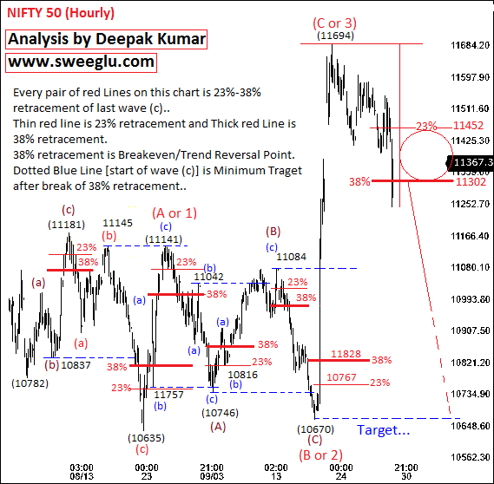Nifty Hourly Chart 1

This is hourly time bar chart of Nifty covering move after 04 Aug 2019 low 10782 till the closing on 01 Oct 2019. I took this recent chart so that readers can check and back test themselves. On this chart:

All the thin Red Lines are 23% retracement of last wave (c).

All the thick Red Lines are 38% retracement of last wave (c) [breakeven Point).

All the Blue Dotted Line are minimum Targets after break of 38% retracement.

But before going further, let us explained what the word “retracement” is and what do we mean by 23%-38% retracement.

**Retracement:** Retracement is referred as a percentage of reversal of a particular wave. The 23%-38% retracement of wave (c) means 23%-38% reversal of wave (c).

Example: Suppose wave (c) is from 10837 to 11181, then wave (c) is of 344 points (11181-10837). 23%-38% of 344 points is approx 82-132 points. We need to subtract these 82-132 points from the end of wave (c) then levels falls at 11099-11049. This 11099-11049 is 23%-38% retracement of wave (c) in this case.

Now let us explain same conditions and calculations on this Nifty hourly chart 1. We marked 23%-38% retracements with red lines but we didn’t write the values for the sake of clarity. Values are explained in explanation below. It might be difficult for you to understand the charts by just looking at it, but don’t be confused and read chart step by step with us as we explained below.

**Look carefully at chart and try to identify the bounce from 10782-11181:-**

You can see that this bounce from 10782-11181 is 3 waves move which we marked as (a), (b) and (c) in brown letters. Wave (a) started from 10782 whereas wave (c) started from 10837 and ended at 11181. Wave (c) is from 10837-11181.

23%-38% retracement of wave (c) [from 10837-11181] is placed at 11099-11049. Please look carefully at decline after 11181 and observe that 38% retracement 11049 (thick Red Line) is broken and then Nifty bounced back to enter in 11049-11099 range (38%-23%) and then declined back twice by 100-140 points from 11049-11099 range. It again entered third time in 11049-11099 range, registered high 11146 and then declined back to achieved minimum downside target 10837 [Start of wave (c)].

**Now look carefully at decline from 11181-10637: –**

You can see that decline from 11181-10637 is 3 wave move which I marked as wave (a), (b) and (c) in Red letters. Wave (c) is from 11145-10637.

23%-38% retracement of wave (c) [from 11145-10637] is placed at 10756-10831. Please look carefully at bounce after 10637 and observe that 38% retracement 10831 (thick Red Line) is broken and then Nifty declined back to enter in 10831-10756 range (38%-23%), registered low 10757 and then bounced back to almost achieved minimum upside target 11145 [Start of wave (c)]. Nifty bounced till 11141.

**Now look carefully at bounce from 10637-11141: –**

You can see that bounce from 10637-11141 is 3 wave move which I marked as wave (a), (b) and (c) in Blue letters. Wave (c) is from 10757-11141.

23%-38% retracement of wave (c) [from 10757-11141] is placed at 11050-10994. Please look carefully at decline after 11141 and observe that 38% retracement 10994 (thick Red Line) is broken and then Nifty bounced back to enter in 10994-11050 range (38%-23%), registered high 11042 and then declined back to achieved minimum downside target 10757 [Start of wave (c)]. Nifty declined till 10746.

**Now look carefully at decline from 11141-10746: –**

You can see that decline from 11141-10746 is 3 wave move which I marked as wave (a), (b) and (c) in Blue letters. Wave (c) is from 11042-10746.

23%-38% retracement of wave (c) [from 11042-10746] is placed at 10815-10859. Please look carefully at bounce after 10746 and observe that 38% retracement 10859 (thick Red Line) is broken and then Nifty declined back to enter in 10859-10815 range (38%-23%), registered low 10816 and then bounced back to achieved minimum upside target 11042 [Start of wave (c)]. Nifty bounced till 11084.

**Now look carefully at bounce from 10746-11084: –**

You can see that bounce from 10746-11084 is 3 wave move which I marked as wave (a), (b) and (c) in Blue letters. Wave (c) is from 10816-11084.

23%-38% retracement of wave (c) [from 10816-11084] is placed at 11020-10981. Please look carefully at decline after 11084 and observe that 38% retracement 10981 (thick Red Line) is broken and then Nifty bounced back to enter in 10981-11020 range (38%-23%), registered high 11016 and then declined back to achieved minimum downside target 10816 [Start of wave (c)]. Nifty declined till 10670.

**Now, move to bit bigger pattern and have a careful look at decline from 11141-10637:-**

This decline from 11141-10637 looks like a 3 waves move with wave (A) completed from 11141-10746, wave (B) completed from 10746-11084 and wave (C) completed from 11084-10637, we marked it in brown colour.

23%-38% retracement of wave (C) is placed at 10767-10828. 38% retracement 11828 was broken and minimum upside target 11084 (start of wave C) was achieved but Nifty didn’t enter in 10828-10767 range (38%-23% retracement) before bouncing towards targets this time.

**Now, move to further bigger pattern and have a careful look at overall bounce from 10637-11694:-**

This bounce from 10637-11694 looks like a 3 waves move with wave (A or 1) completed from 10637-11141, wave (B or 2) completed from 11141-10670 and wave (C or 3) completed from 10670-11694, we marked it in Red letters.

23%-38% retracement of wave (C or 3) is placed at 10452-11302. 38% retracement 11302 is broken on 01 Oct 2019. So according to “Sweeglu Elliott Waves 38% retracement breakout strategy” 11302-11452 is immediate resistance and 10670 is minimum downside target. Now, it is your work to see how Nifty reacted on 03 and 04 Oct or how it is going to react in coming days or if it will achieve target 10670 or not.

Please observe the calculations on charts carefully and see that in all the 3 waves (abc) move, trend changed after break of 38% retracement of wave (c), 38%-23% retracement changed from Support to Resistance or Resistance to Support every time, Nifty entered in 38%-23% retracement and reverse back till start of wave (c).

There is only one case when Nifty breached 23% mark after break of 38% (first case), otherwise Nifty didn’t even breach 23% mark in other cases. 38%-23% acted as most effective Support/resistance most of the time.

The proof and importance of 38% retracement breakout is there on this hourly chart. It didn’t happen just once or twice but repeated several time on same chart within 1 and half month. It happened about 6-7 times in 45 days on hourly chart but if you see on 5 minutes chart then this pattern repeats on daily basis.

**Let us go deeper and show more examples within the same move on separate chart:**

Look carefully at decline from 11181-10637 on above hourly chart. I am zooming out the chart and showing same move on separate hourly chart below.

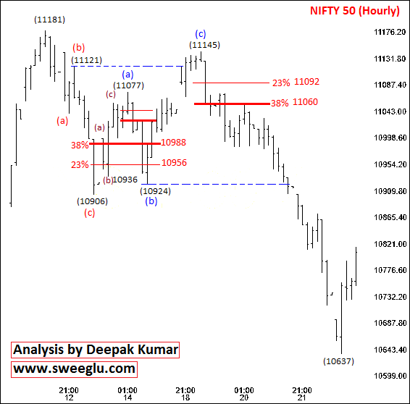Nifty Hourly Chart 2

This is again hourly time bar chart of Nifty covering decline from 11181-10637. I zoomed in this move separately to show that same pattern is repeated on this chart 3-4 times within this move.

Look carefully at (abc) decline from 11181-10906 with wave (c) from 11121, then look carefully at (abc) bounce from 10906-11077 with wave (c) from 10936-11077, then look carefully at (abc) bounce from 10906-11145 with wave (c) from 10924-11145.

Read the chart step by step same as I explained earlier and check yourself how Nifty reacted after break of 38% retracement of wave (c).

We are writing this Article on 06 Oct 2019, so let us show you the example of very last session which happened this Friday on 04 Oct 2019.

The trade suggestion was sent to Live Update Subscribers on 04 Oct 2019 by WhatsApp Broadcast:

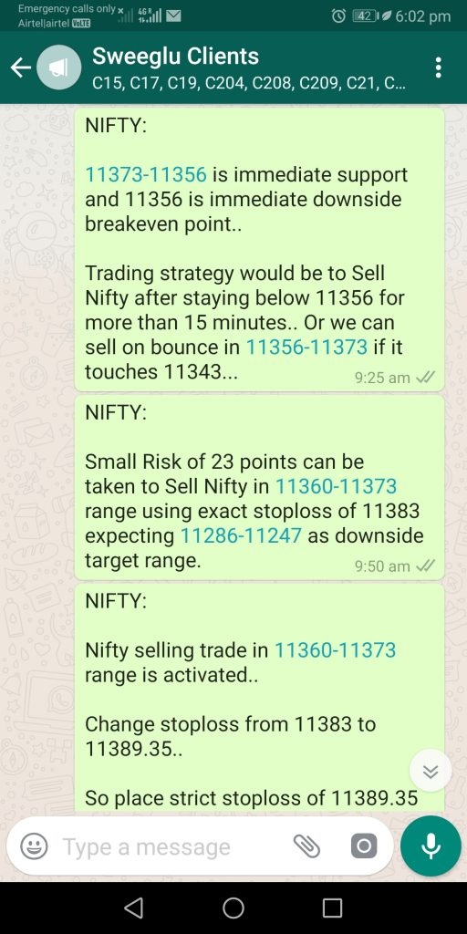

You can read the wording of trade suggestion in the WhatsApp screenshot above. The reason and calculations for this trade suggestion is explained on next chart:

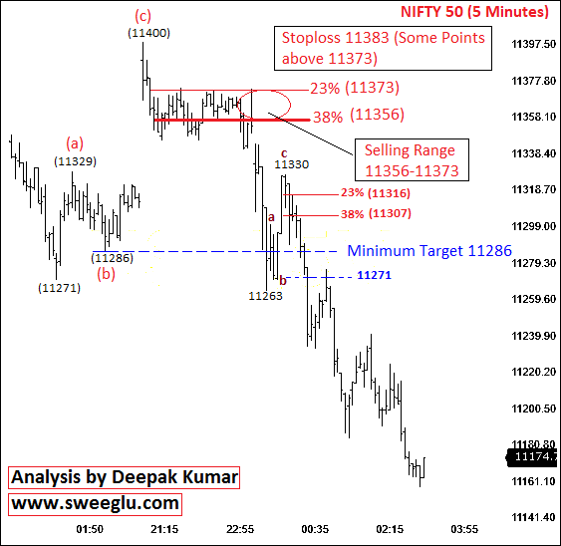

This is 5 minutes time bar chart of Nifty covering Intraday move of 04 Oct 2019. Now read this chart carefully and read on wording of trade suggestions carefully. Match the trade suggestion with chart and observe yourself how Nifty reacted.

We are suggesting readers to calculate and observe the reaction themselves because readers will get practical experience by doing it.

Also observe the bounce from 11263-11330 on this 5 minutes chart and observe the same pattern within this move. Nifty gave 02 low risk trading opportunities based on 38% retracement strategies in a single day. You may find more than twice such type of pattern in the same move if you see it on 1 minute chart.

This strategy is explained on Nifty Charts, but if you invest some time and observe yourself then same pattern forms on Bank Nifty, Stocks, Currencies and Commodities too. This article will turn into a book if I explained more.

**Key Points of 38% Retracement Strategy of Sweeglu Elliott Waves:**

1. Whenever there is a 3 waves move, 23%-38% retracement of 3rd wave is most effective support/resistance and 38% retracement is most effective trend reversal point. No other analysis gives such effective trend reversal point.

* 23%-38% retracement of 3rd wave becomes most effective resistance/support (resistance becomes support and support becomes resistance) after break of 38% retracement and price mostly reverse till the start point of 3rd wave.
* Price rarely reverse back beyond 23% mark after successful break of 38% retracement. It makes 38%-23% as most effective and low risks entry levels for trade.
* We can still earn good profit even if we are wrong at counting waves. If you have knowledge of Elliott Wave Theory then you will see that overall Elliott Wave Counts and Patterns are wrong on hourly chart in some cases but this strategy is still giving profit. That is the reason I declared it most profitable and accurate trading strategy because profit can be earned even if are wrong at identifying the whole pattern.

**Planning Low Risk Trades based on Sweeglu Elliott Waves 38% Retracement Breakout Strategy:**

The best Low Risk High rewarding trading strategy is to wait for successful break of 38% retracement of 3rd wave and then wait to buy/sell in 38%-23% range with stoploss some points beyond 23% mark for minimum target of start point of 3rd wave.

Or wise traders can make their own trading strategy according to their Capital Limit, Risk Tolerance and Trading style. We might not be good at making trade plans but we gave you a precious diamond from our treasure of experience, you can make even better trade plans than us. We gave you an idea for your research, it is up to you how deep you can go.

**Accuracy of Sweeglu Elliott Waves 38% Retracement Breakout Strategy:**

We never focus or care about accuracy because accuracy is not practically applicable on analysis methods. Even we encourage our clients/students to ignore the word “Accuracy”. Accuracy is just a marketing word promoted by Stock Market advisor to lure clients, otherwise it doesn’t have any significance. Wise traders talks about Risk Reward, they never care about accuracy.

This trading strategy gives minimum risk reward of 1:2 and traders can be in profit even if 30%-40% of the trades go right. This is how we answer if you ask about accuracy.

Otherwise, we are not giving you trading recommendations but we gave you our Skills and Experience. You can observe and calculate the accuracy yourself.

**Who can use Sweeglu Elliott Waves 38% Retracement Breakout Strategy?**

This trading strategy is back tested for years and works in any market conditions, it works more efficiently when the overall pattern is complex and when world is struggling to identify market moves accurately. But those who knows the rules of Sweeglu Elliott Waves can only use this strategy perfectly because you can’t mark any move as 3 waves or (a), (b), (c).  There are definite rules and calculations to mark a move as (abc) and this strategy works perfect only when you are able to identify a 3 waves (abc) move perfectly. Otherwise any one can use it because you can still identify a (abc) move casually some times even if you donlt know the rules but those who know the rules or (abc) wave can use it most effectively.

For Sweeglu Elliott Waves Book Subscribers and Students, there is nothigh new in this Sweeglu Elliott Waves 38% retracement breakout trading strategy. It is the same which I had explained in chapters “Importance of 38% retracement” and “Alternate Wave Counts”. And I am showing the same things in every of my analysis report. If you read the book carefully and observe my daily analysis reports then you will find that we are doing the same thing every next day. This 38% retracement breakout trading strategy is just the further extension of the chapter “Importance of 38% retracement” with recent practical examples.

This Sweeglu Elliott Waves 38% retracement breakout trading strategy is not all about Elliott Wave Theory. This is just a precious diamond from the treasure of our years of research and experience. Otherwise it is not even 10% or Elliott Wave Theory.

There are other many other trading strategies based on 3-3-5 Flat Corrections, Irregular Correction, Triple Zigzag Correction, extended wave 5, Leading Diagonal etc. All these trading strategies are even more effective for different type of trades in different type of conditions. Some strategies can identify sharp moves suitable for buying options and some are most effective to identify point to point reversal.

**The Real Life Practical Application of Elliott Wave Theory in Trading:**

We “Sweeglu Elliott Waves” never care about what is written in books and what is written in theory. Anything which work for us is our rule and our focus is always on practical Application of Elliott Wave Theory. Our rules of Elliott Wave Theory may be different because we eliminated which doesn’t work practically and refined which worked best for us. The aim of any analysis method is to identify low risk profitable trades from this market, having theoretically knowledge and making guesses doesn’t work for traders.

We always practiced and taught Practical Application of Elliott Wave Theory and we are doing the same since years. This Sweeglu Elliott Waves 38% retracement breakout trading strategy is one of the masterpieces of our Practical Application of Elliott Wave Theory which we are sharing free to everyone.

**Where can you learn Practical Application of Elliott Wave Theory?**

We assume everyone here is intelligent enough to take decision where or how they can learn. We can just give our advice and suggestions. There are many institutions and trainers who just have bookish/theoretical knowledge but are not able to apply it practically. Please refer trainer’s work and see how he/she is applying Elliott Wave Theory on real time charts and how they are planning trades based on their analysis. Just plotting the waves on charts doesn’t work, trainer must be able to plan Low Risk trades with exact entry levels, stoploss and targets based on the analysis.

**If you are interested in our way of analysis then you have 3 options:**

**Sweeglu Elliott Wave Website and Sweeglu Elliott Waves Face book page:** If you don’t have money but you are dedicated enough to invest your time then you can learn free from our Website and Facebook Page. We never keep secret and we post detailed Elliott Wave Analysis Reports of Nifty and Bank Nifty regularly on our website. If you observe carefully then everything is available free on our website. But it can take months or years to decode and arrange the rules but learning is possible.

Link to our Facebook page is <https://www.facebook.com/sweegluEWT> . Like the page to get out regular Nifty and Bank Nifty Updates based on Elliott Wave Theory.

We post detailed Elliott Wave Analysis Report of Nifty at <http://sweeglu.com/category/nifty/>

You can read educational articles to get awareness about Elliott Wave Theory at <http://sweeglu.com/category/ewt-articles/>

**Practical Application of Elliott Wave Principle Book**: If you can invest some money and can read the book and analysis reports then we are proving everything about Elliott Wave Theory and its practical application with our personal techniques in the form of eBook in well arranged manner. Whatever you can learn from website in years can be known in days/weeks through the book.  Furthermore, our Analysis Reports and Life Time Support will help further for faster learning. The complete details about the book subscription is at <http://sweeglu.com/learn-elliott-wave-analysis/>

**3 days Offline Workshop:** If you are really serious about stock market and want to proceed professionally then we are also providing 03 days offline workshops in major Indian Cities with 03 Months Live Market Analysis Updates and life time support. Our one on one dedicated coaching can train you to the professional levels within weeks or months. Face to face learning is faster and more efficient. The same techniques and rules can be understood more effectively within hours in face to face learning which takes months to understand by reading book. Further there are many things and techniques which cannot be explained in writing. Details about our upcoming training workshops is at <http://sweeglu.com/elliott-wave-training/>

Further wise people can reason out, if we can explain this 38% retracement strategy with this precision in writing then how good we are at face to face teaching.

**Get the Copy “Sweeglu Elliott Waves 38% Retracement Breakout Trading Strategy” in PDF Format**

Reader if interested can ask for the copy of “Sweeglu Elliott Waves 38% Retracement Breakout Trading Strategy” in PDF format by sending us email at sweeglu@gmail.com or on WhatsApp at 8082165121.

Those who want our Fibonacci Retracements/Projections calculator (Excel Sheet) for quick calculations can request for the same. We can send it by email for free